**CURRICULUM VITAE**

**(**Bachelor’s degree of INFORMATION TECHNOLOGY)

Mr **:** Walid Bourbia

**Nationality**: Algeria

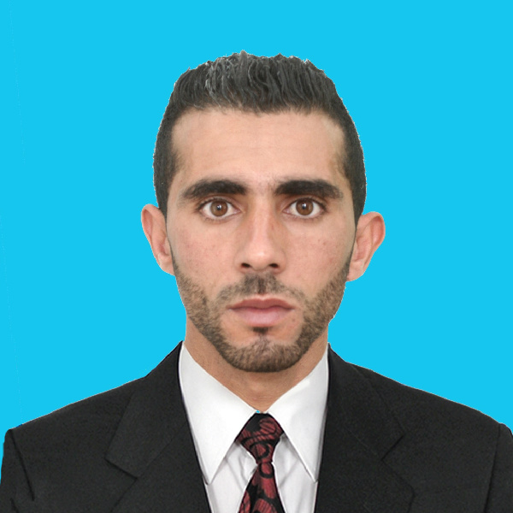

**DATE-of-Birth**: 22/01/1990

**Phone**: 33349675

**Email**: [walid.b.inf@gmail.com](mailto:walid.b.inf@gmail.com)

Location: Old Al-Ghanim, Doha

**DEGREES OBTAINED:**

* Bachelor’s degree in INFORMATION TECHNOLOGY from the faculty of exact science_ University of Jijel – Algeria 2014
* High school degree in nature life sciences – Algeria 2010
* Effective Secretary – Practical Workshop – Qatar 2016

**EXPERIENCE**

* Employee of an IT company 25/08/2014-20/09/2016 in Algeria

**Completed tasks**

* Assist in the conclusion of contracts and agreements.
* Good communication with partners, both private and government institutions.
* Receiving and responding to telephone calls.
* Print & scan files & word processing.
* Accounting business for several construction companies
* Sale of computer and suffixes and parts.
* Maintenance of system and computer software.
* Maintenance of computer hardware.
* School registrations and different registration on the network…
* Project Graduation 2014
* Work on the project application conversation and share files using: javaneatbeans + SQL + Microsoft access(db).
* Teacher in math & computer (private classes) Middle school.

**LANGUAGES :**

* English : Good.
* Arabic : Very Good. Mother tong.
* French : Very Good.

**KEY STRENGTHS & SKILLS:**

* Professional skills in MS Office (Word, Excel, Access, Power Point )
* Able to explain and solve the problems
* Computer literate with extensive IT knowledge.
* Experience of using a scanner.
* Comprehensive understanding of the Data Protection Act.
* The ability to plan and prioritise time and activities
* An ability to work to deadlines whilst ensuring accuracy and efficiency.
* Data entry skills & Auditing.
* Data management & Data mining.

**Special Abilities**

* able to work on own initiative are as part of team & can deal with administrative duties competently.
* Programming languages JAVA, C, C++, PHP, HTML,DELPHI…
* The spirit of responsibility.
* Methodical & Attention to detail.
* Good physical condition & Able to work the day like night.
* quick learner of new technologies & good team member with management skills.
* Planning and regulation, follow-up, communication and dealing with others, decision making and reporting.
* Good manners and dealing, quiet and active.

**Other job skills:**

* Experience working with OS: XP & Windows 7,8,10 & Android & linix.
* The ability to create programs and smart application.
* Computer assembling and maintenance.

**Hobbies:**

Swimming, gymnastics and photography.

**I am honored to be a part of your own team and I wish I could gain your trust….With my sincere thanks and appreciation.**

**I am honored to be a part of your own team and I wish I could gain your trust….With my sincere thanks and appreciation.**